Practical no 9
Create the Data staging area for the selected database using SQL.

a] Create a staging database and a staging table:

- create database staging;
- use staging
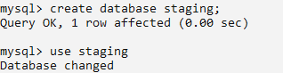

- create table stage_primary_data(id int(3) primary key auto_increment,name varchar(50),address varchar(40),pin varchar(5));
- describe stage_primary_data;
- insert into stage_primary_data(name,address,pin) values ("Kalpaj Phansalkar","Kankavli",'412');
- insert into stage_primary_data(name,address,pin) values ("Tejas Redkar","Kankavli",'35');
- insert into stage_primary_data(name,address,pin) values ("Sairaj Patkar","Kudal",'6969');
- insert into stage_primary_data(name,address,pin) values ("Ricky Fernandis","Kasal",'11111');
- select * from stage_primary_data;
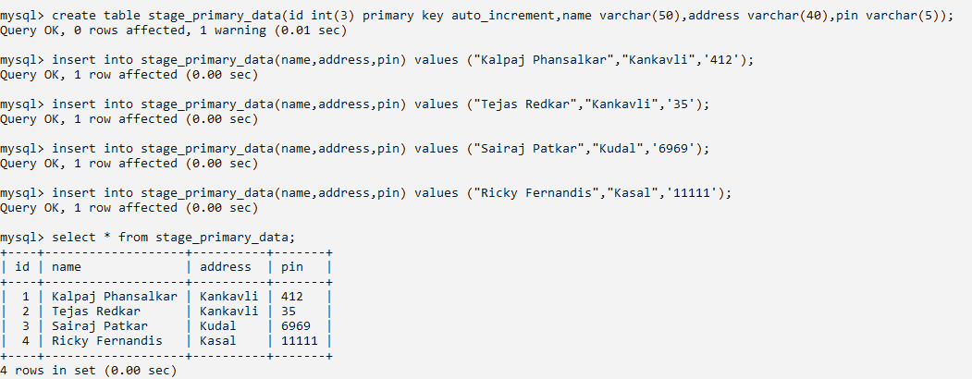
- update stage_primary_data set pin=right(concat("00000",pin),5);
- select * from stage_primary_data;
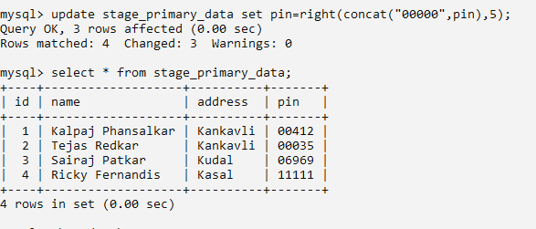

b] Create a database for data storage:

- create database data_storage;
- use data_storage;
- create table process_primary_data(id int(3) primary key auto_increment,name varchar(50),address varchar(40),pin varchar(5));


c]insert the data into the other database from the staging database:

- INSERT INTO process_primary_data SELECT * FROM staging.stage_primary_data;
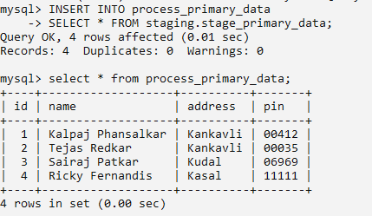
- select * from process_primary_data;

